PRACTICAL FILE
SESSION: 2023-24
Computer Networks Lab
(CIC 355)

III Year, V Sem

Submitted to: Submitted by:
Name: Dr. Kimmi Verma Name: Adityan Verma
Designation: Associate Professor Enrollment No. 07818002721

INDEX

S.NO. | PROGRAM NAME | DATE OF EXPERIMENT | DATE OF SUBMISSION | SIGN.
1 | Introduction to Networking Simulation Tools: Cisco Packet Tracer
2 | Study of Network Devices in Detail
3 | Study of basic network command and Network configuration commands.
4 | a) To configure a Bus Topology  Network using CISCO Packet Tracer  Software.  b) To Configure a star Topology  network using CISCO packet tracer  software.  c) To Configure a Ring Topology  network using CISCO packet tracer  software.  d) To Configure a Mesh Topology  network using CISCO packet tracer  software
5 | To understand the operation of TELNET by accessing the router in server room from a PC.
6 | To implement the static routing using Cisco Packet Tracer.
7 | To implement an IP Addressing Scheme and Subnetting in small networks using Cisco Packet Tracer.
8 | To Connect two LAN networks through Router.
9 | To implement the DHCP onto the Network Topology using Cisco Packet Tracer.
10 | To implement the Email Services in the Network using Cisco Packet Tracer.
11 | To implement the DNS server in the Network using Cisco Packet Tracer.

EXPERIMENT NO. 1
AIM: Introduction to Networking Simulation Tools: Cisco Packet Tracer
Packet Tracer is a protocol simulator developed by Dennis Frezzo and his team at Cisco Systems. Packet Tracer (PT) is a powerful and dynamic tool that displays the various protocols used in networking, in either Real Time or Simulation mode. This includes layer 2 protocols such as Ethernet and PPP, layer 3 protocols such as IP, ICMP, and ARP, and layer 4 protocols such as TCP and UDP. Routing protocols can also be
traced.
Purpose:
The purpose of this lab is to become familiar with the Packet Tracer interface. Learn how to use existing topologies and build your own.
Requisite knowledge:
This lab assumes some understanding of the Ethernet protocol. At this point we have not discussed other protocols, but will use Packet Tracer in later labs to discuss those as well. Version: This lab is based on
Packet Tracer 7.3.

Introduction to the Packet Tracer Interface using a Hub Topology
Step 1: Start Packet Tracer and Entering Simulation Mode 1
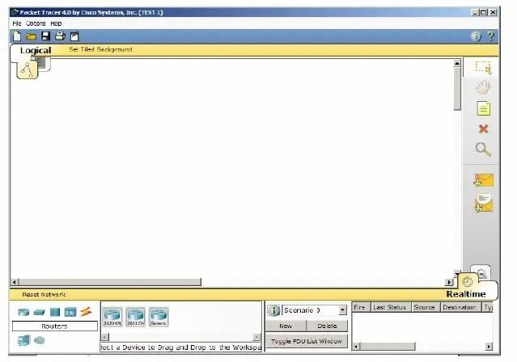
Step 2: Choosing Devices and Connections
We will begin building our network topology by selecting devices and the media in which to connect them. Several types of devices and network connections can be used. For this lab we will keep it simple by using End Devices, Switches, Hubs, and Connections.
Single click on each group of devices and connections to display the various choices

Step 3: Building the Topology – Adding Hosts Single click on the End Devices.
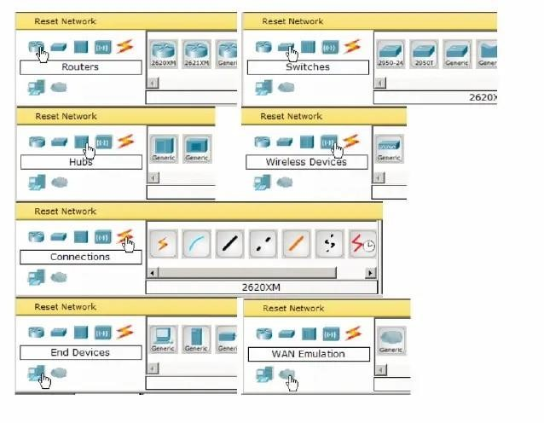
EXPERIMENT NO. 2
AIM: Study of following Network Devices in Detail
- Repeater
- Hub
- Switch
- Bridge
- Router
- Gate Way
Apparatus (Software): No software or hardware needed.
Procedure: Following should be done to understand this practical.
- Repeater: Functioning at Physical Layer. A repeater is an electronic device that receives a signal and retransmits it at a higher level and/or higher power, or onto the other side of an obstruction, so that the signal can cover longer distances. Repeater have two ports, so cannot be use to connect for more than two devices
- Hub: An Ethernet hub, active hub, network hub, repeater hub, hub or concentrator is a device for connecting multiple twisted pair or fiber optic Ethernet devices together and making them act as a single network segment. Hubs work at the physical layer (layer 1) of the OSI model. The device is a form of multiport repeater. Repeater hubs also participate in collision detection, forwarding a jam signal to all ports if it detects a collision.
- Switch: A network switch or switching hub is a computer networking device that connects network segments. The term commonly refers to a network bridge that processes and routes data at the data link layer (layer 2) of the OSI model. Switches that additionally process data at the network layer (layer 3 and above) are often referred to as Layer 3 switches or multilayer switches.
- Bridge: A network bridge connects multiple network segments at the data link layer (Layer 2) of the OSI model. In Ethernet networks, the term bridge formally means a device that behaves according to the IEEE 802.1D standard. A bridge and switch are very much alike; a switch being a bridge with numerous ports. Switch or Layer 2 switch is often used interchangeably with bridge. Bridges can analyse incoming data packets to determine if the bridge is able to send the given packet to another segment of the network.

- Router: A router is an electronic device that interconnects two or more computer networks, and selectively interchanges packets of data between them. Each data packet contains address information that a router can use to determine if the source and destination are on the same network, or if the data packet must be transferred from one network to another. Where multiple routers are used in a large collection of interconnected networks, the routers exchange information about target system addresses, so that each router can build up a table showing the preferred paths between any two systems on the interconnected networks.
- Gate Way: In a communications network, a network node equipped for interfacing with another network that uses different protocols.
  - A gateway may contain devices such as protocol translators, impedance matching devices, rate converters, fault isolators, or signal translators as necessary to provide system interoperability. It also requires the establishment of mutually acceptable administrative procedures between both networks.
A protocol translation/mapping gateway interconnects networks with different network protocol technologies by performing the required protocol conversions.
EXPERIMENT NO. 3
AIM: Study of basic network command and Network configuration commands.
Apparatus (Software): Command Prompt and Packet Tracer.
Procedure: To do this EXPERIMENT- follows these steps:
In this EXPERIMENT- students have to understand basic networking commands e.g. ping, tracert etc.

All commands related to Network configuration which includes how to switch to privilege mode and normal mode and how to configure router interface and how to save this configuration to flash memory or permanent memory.
These commands include
- Configuring the Router commands
- General Commands to configure network
- Privileged Mode commands of a router
- Router Processes & Statistics
- IP Commands
- Other IP Commands e.g. show Ip route etc.

ping:
ping sends an ICMP ECHO_REQUEST packet to the specified host. If the host responds, you get an ICMP packet back. Sound strange? Well, you can “ping” an IP address to see if a machine is alive. If there is no response, you know something is wrong.
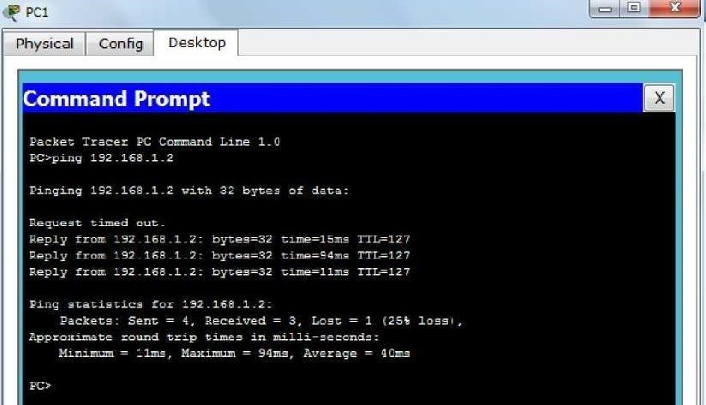
Traceroute:
Tracert is a command which can show you the path a packet of information taken from your computer to one you specify. It will list all the routers it passes through until it reaches its destination, or fails to and is discarded. In addition to this, it will tell you how long each 'hop' from router to router takes.
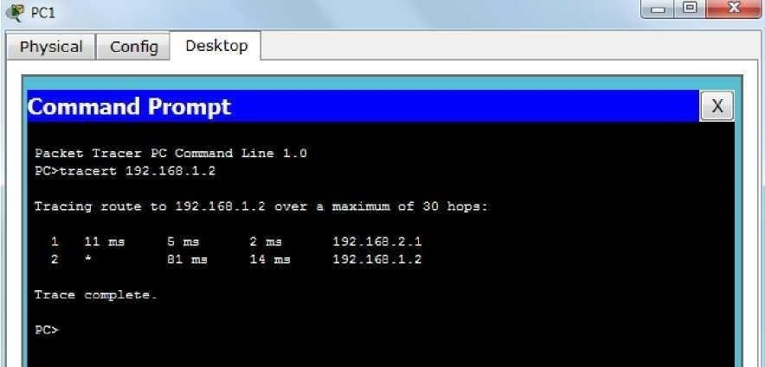

nslookup:
Displays information from Domain Name System (DNS) name servers.
NOTE :If you write the command as above it shows as default your pc's server name firstly.

pathping:
A better version of tracert that gives you statics about packet lost and latency.
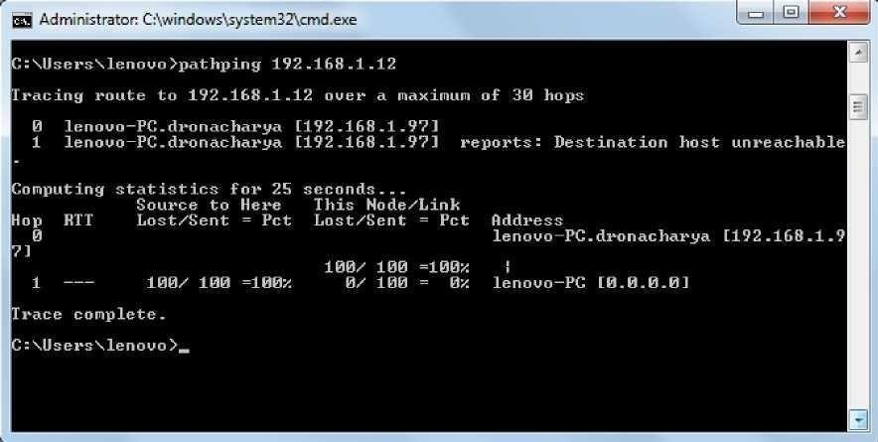
Getting Help:
In any command mode, you can get a list of available commands by entering a question mark
(?). Router>?
To obtain a list of commands that begin with a particular character sequence, type in those characters followed immediately by the question mark (?).
Router#co?

configure connect copy:
To list keywords or arguments, enter a question mark in place of a keyword or argument. Include a space before the question mark.
Router#configure ? memory Configure from NV memory network Configure from a TFTP network host terminal Configure from the terminal .
You can also abbreviate commands and keywords by entering just enough characters to make the command unique from other commands. For example, you can abbreviate the show command to sh.

Configuration Files:
Any time you make changes to the router configuration, you must save the changes to memory because if you do not, they will be lost if there is a system reload or power outage. There are two types of configuration files: the running (current operating) configuration and the startup configuration.
Use the following privileged mode commands to work with configuration files.
EXPERIMENT NO. 4
AIM: a) To configure a Bus Topology Network using CISCO Packet Tracer Software.
Packet tracer: Packet Tracer is a cross-platform visual simulation tool designed by Cisco Systems that allows users to create network topologies and imitate modern computer networks. The software allows users to simulate the configuration of Cisco routers and switches using a simulated command line interface. Packet Tracer makes use of a drag and drop user interface, allowing users to add and remove simulated network devices as they see fit.
Bus Topology: Bus topology is a network type in which every computer and network devices is connected to single cable.
Advantages:
- The bus topology is easy to understand, install, and use for small network.
- Cable required is least compared to other network topology.
- Cost effective.
- Easy to joining two cables together.
Disadvantages:
- Entire network shuts down if there is a break in the main cable.
- Terminators are required at both ends of the backbone cable.
- Difficult to identify the problem if the entire network shuts down.
- Not meant to be used as a stand-alone solution.

Introduction to the Packet Tracer Interface using a Bus Topology
Step 1: Start Packet Tracer and Entering Simulation Mode 1
Step 2: Choose switch then select generic
Step 3: After selecting generic click on the main area.
Step 4: Select end devices and then click on generic.
Step 5: click at workspace to see the PC.
Step 6: select connections from power cycle devices and click on automatically choose connection type.
Step 7: Draw connections from switch to PC.
Step 8: Double click on a PC, a box will appear, click on the Desktop tab. Step 9: Then select IP configuration.
Step 10: Write the IP address of your network and click at the Subnet mask filed. Subnet mask will appear automatically.
Step 11: Repeat step 10 to set the IPs for all the PCs.
Step 12: now add a router and repeat the above step for connecting second LAN.
Step 13: Select “ADD simple message”.
Step 14: Drag and drop the message to the source device and then to the destination device.
Step 15: Select the simulation mode at the bottom right corner. Step 16:
Click at “Auto capture/play”
Step 17: Observe the path of the message from source to switch. Then to all devices and then move to the destination.
Step 18: Finally observe the marks. If the source PC is marked correct it means you have successfully established connection.

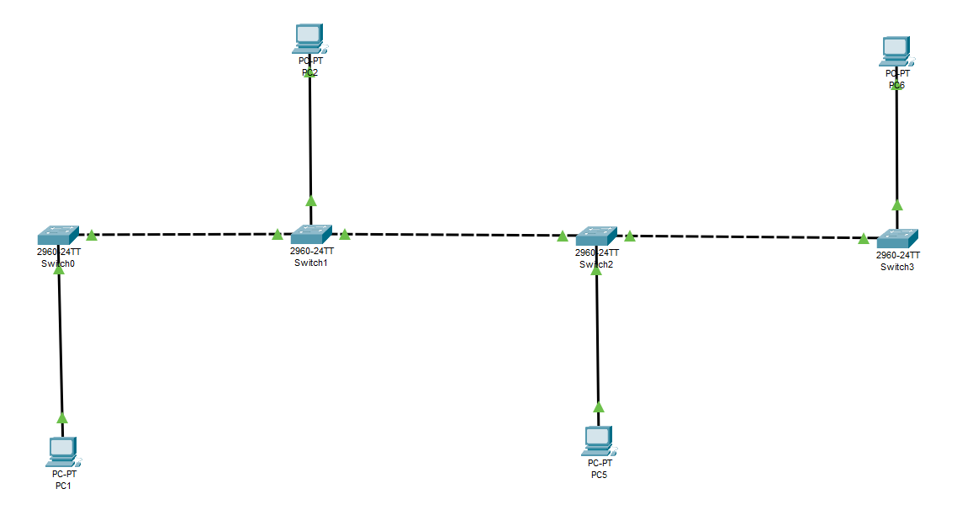
b) To Configure a star Topology network using CISCO packet tracer software.
Packet tracer: Packet Tracer is a cross-platform visual simulation tool designed by Cisco Systems that allows users to create network topologies and imitate modern computer networks. The software allows users to simulate the configuration of Cisco routers and switches using a simulated command line interface. Packet Tracer makes use of a drag and drop user interface, allowing users to add and remove simulated network devices as they see fit.
Star Topology: A star topology is a topology for a Local Area Network (LAN) in which all nodes are individually connected to a central connection point, like a hub or a switch. A star takes more cable than e.g. a bus, but the benefit is that if a cable fails, only one node will be brought down.
Advantages:
- Low network traffic.
- No disruptions to the network when connecting or removing devices.
- Easy to detect faults and to remove parts.
Disadvantages:
- Requires more cable length than a linear topology.
- If the hub, switch, or concentrator fails, nodes attached are disabled.
- More expensive than linear bus topologies because of the cost of the hubs, etc.
Introduction to the Packet Tracer Interface using a Star Topology
Step 1: Start packet tracer
Step 2: Choose Hub then select generic
Step 3: After selecting generic click on the main area.
Step 4: Select end devices and then click on generic.
Step 5: click at workspace to see the PC.
Step 6: select connections from power cycle devices and click on automatically choose connection type.
Step 7: Draw connections from switch to PC.
Step 8: Double click on a PC, a box will appear, click on the Desktop tab.
Step 9: Then select IP configuration.
Step 10: Write the IP address of your network and click at the Subnet mask filed. Subnet mask will appear automatically.
Step 11: Repeat step 10 to set the IPs for all the PCs.
Step 12: now add a router and repeat the above step for connecting second LAN.
Step 13: Select "ADD simple message".
Step 14: Drag and drop the message to the source device and then to the destination device.
Step 15: Select the simulation mode at the bottom right corner.
Step 16: Click at "Auto capture/play"
Step 17: Observe the path of the message from source to switch. Then to all devices and then move to the destination.
Step 18: Finally observe the marks. If the source PC is marked correct it means you have successfully established connection.

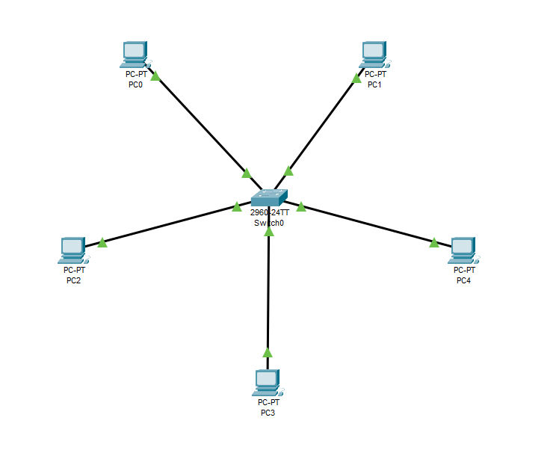

c) To Configure a Ring Topology network using CISCO packet tracer software.
Packet tracer: Packet Tracer is a cross-platform visual simulation tool designed by Cisco Systems that allows users to create network topologies and imitate modern computer networks. The software allows users to simulate the configuration of Cisco routers and switches using a simulated command line interface. Packet Tracer makes use of a drag and drop user interface, allowing users to add and remove simulated network devices as they see fit.
Ring Topology: A ring topology is a network configuration in which device connections create a circular data path. Each networked device is connected to two others, like points on a circle. Together, devices in a ring topology are referred to as a ring network.
Advantages:
- Cheap to install and expand.
- No one is master in the Network.
- Data can transfer between workstations at high speeds.
- Additional workstations can be added without impacting performance of the network.
Disadvantages:
- Design complex compare to Bus topology.
- Single node failure collapse full network.
- Failure of one computer disturbs the whole network.
Introduction to the Packet Tracer Interface using a Ring Topology
Step 1: Start packet tracer
Step 2: Choose switch then select generic.
Step 3: After selecting generic click on the main area.
Step 4: Select end devices and then click on generic.
Step 5: Click at workspace to see the PC.
Step 6: Select connections from power cycle devices and click on automatically choose connection type.
Step 7: Draw connections from switch to PC.
Step 8: Double click on a PC, a box will appear, click on the Desktop tab.
Step 9: Then select IP configuration.
Step 10: Write the IP address of your network and click at the Subnet mask filed. Subnet mask will appear automatically.
Step 11: Repeat step 10 to set the IPs for all the PCs.
Step 12: Select "ADD simple message".
Step 13: Drag and drop the message to the source device and then to the destination device.
Step 14: Select the simulation mode at the bottom right corner.
Step 15: Click at "Auto capture/play"
Step 16: Observe the path of the message from source to switch. Then to all devices and then move to the destination.
Step 17: Finally observe the marks. If the source PC is marked correct it means you have successfully established connection.

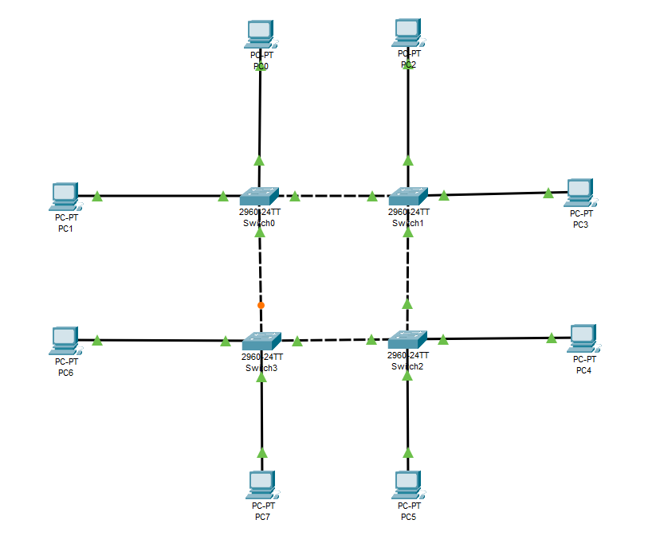
d) To Configure a Mesh Topology network using CISCO packet tracer software.
Packet tracer: Packet Tracer is a cross-platform visual simulation tool designed by Cisco Systems that allows users to create network topologies and imitate modern computer networks. The software allows users to simulate the configuration of Cisco routers and switches using a simulated command line interface. Packet Tracer makes use of a drag and drop user interface, allowing users to add and remove simulated network devices as they see fit.
Mesh Topology: A mesh topology is a network topology in which all the network nodes are individually connected to most of the other nodes. There is not a concept of a central switch, hub or computer which acts as a central point of communication to pass on the messages.
A fully connected mesh topology has all the nodes connected to every other node. If you know the graph theory, then it is like a fully connected graph where all the nodes are connected to every other node. On the other hand, a partially connected mesh topology does not have all the nodes connected to each other.
Advantages:
- Each connection can carry its own data load.
- It is robust.
- A fault is diagnosed easily
- Provides security and privacy
Disadvantages:
- Installation and configuration are difficult if the connectivity gets more
- Cabling cost is more and the most in case of a fully connected mesh topology
- Bulk wiring is required
Introduction to the Packet Tracer Interface using a Mesh Topology
Step 1: Start packet trace.
Step 2: Choose switch then select generic.
Step 3: After selecting generic click on the main area.
Step 4: Select end devices and then click on generic.
Step 5: click at workspace to see the PC.
Step 6: select connections from power cycle devices and click on automatically choose connection type.
Step 7: Draw connections from switch to PC.
Step 8: Double click on a PC, a box will appear, click on the Desktop tab.
Step 9: Then select IP configuration.
Step 10: Write the IP address of your network and click at the Subnet mask filed. Subnet mask will appear automatically.
Step 11: Repeat step 10 to set the Ips for all the PCs.
Step 12: Select “ADD simple message”.
Step 13: Drag and drop the message to the source device and then to the destination device.
Step 14: Select the simulation mode at the bottom right corner.
Step 15: Click at "Auto capture/play"
Step 16: Observe the path of the message from source to switch. Then to all devices and then move to the destination.
Step 17: Finally observe the marks. If the source PC is marked correct it means you have successfully established connection.

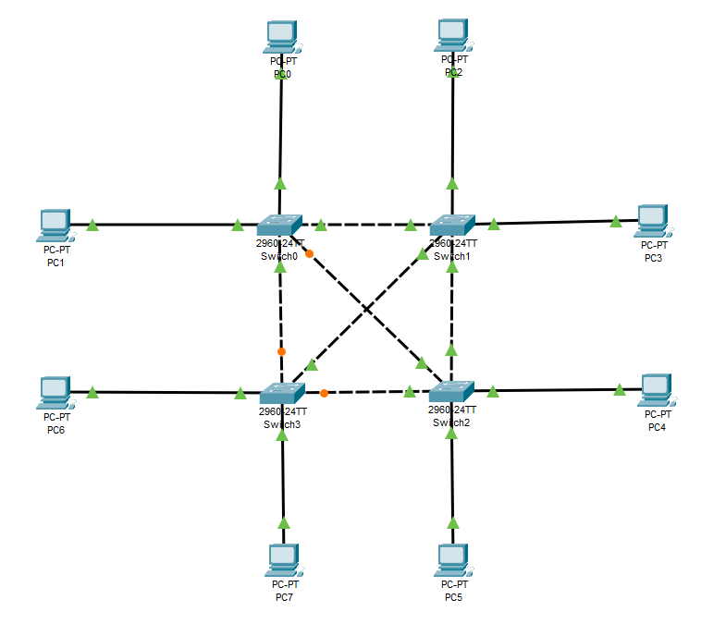

EXPERIMENT NO. 5
AIM: To understand the operation of TELNET by accessing the router in server room from a PC.
THEORY: -
Telnet:
- Telnet is an application layer protocol that allows a network administrator to access and manage remote devices.
- A user on a client machine can use a software (also known as a Telnet client) to access a command-line interface of another, remote machine that is running a Telnet server program.
- A network administrator can access the device by telnetting to the IP address or hostname of a remote device. The network administrator will then be presented with a virtual terminal that can interact with the remote host.
STEPS: -
- For PC choose fast Ethernet and for Router choose Gigabit ethernet 0/0/0
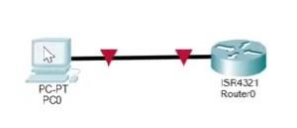

- Setting in end device
Choose Ip config from desktop from the end device
Set the Ip address, subnet mask and default gateway as shown.

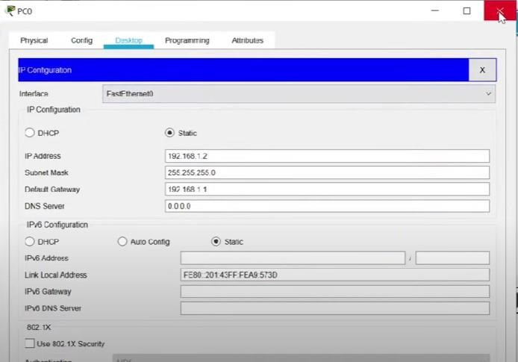

- Setting in Router
Choose CLI then type the following
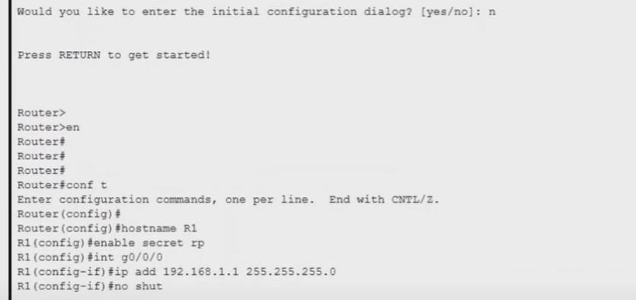

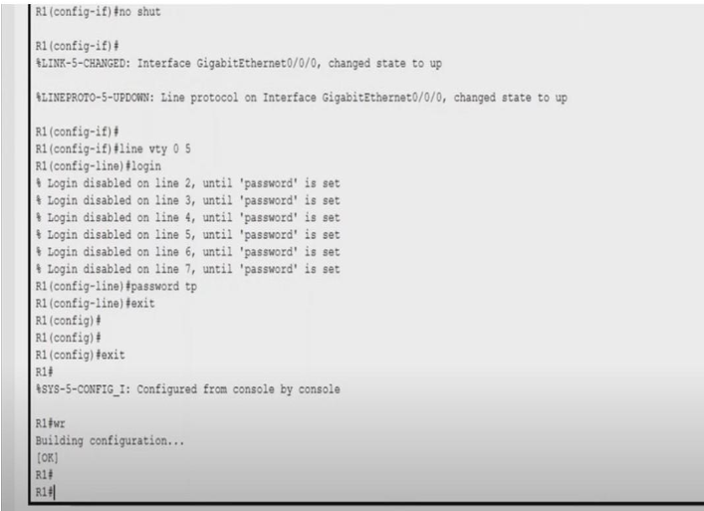

- In the pc
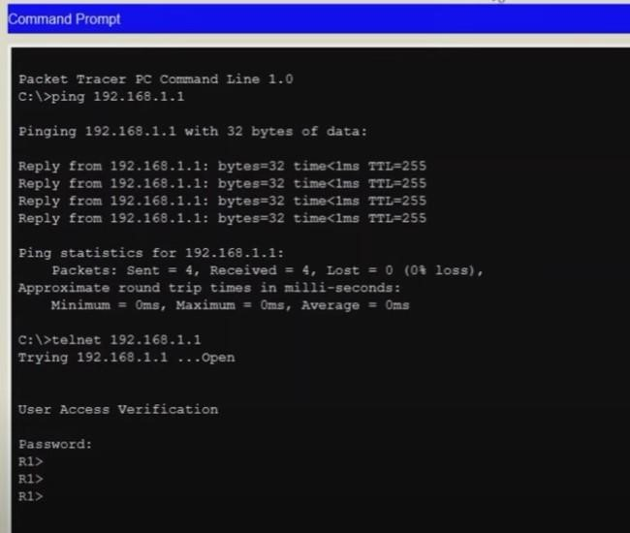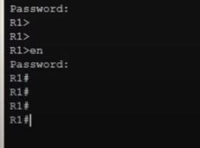

EXPERIMENT NO. 6
AIM: To implement the static routing using Cisco Packet Tracer.
Static routing:
Static routing is a form of routing that occurs when a router uses a manually-configured routing entry, rather than information from dynamic routing traffic.
Steps:
Develop the network using two routers (1841) from networking devices, two switches (2950-24) from networking devices and 4 PCs from end devices.
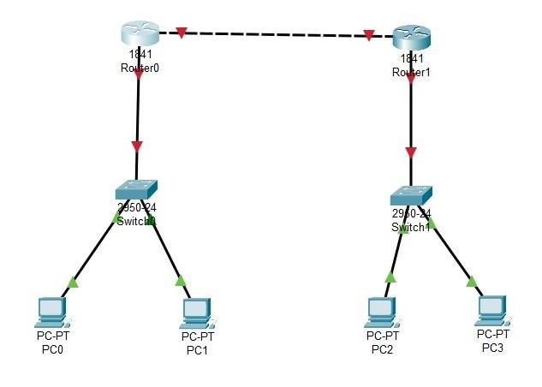

Here in total three networks are there
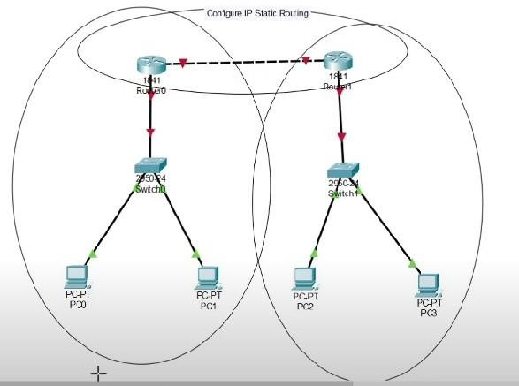

Next step is configuration
In all the four PC IP addresses are set. Two in one network and two is another (Desktop-IP configuration)
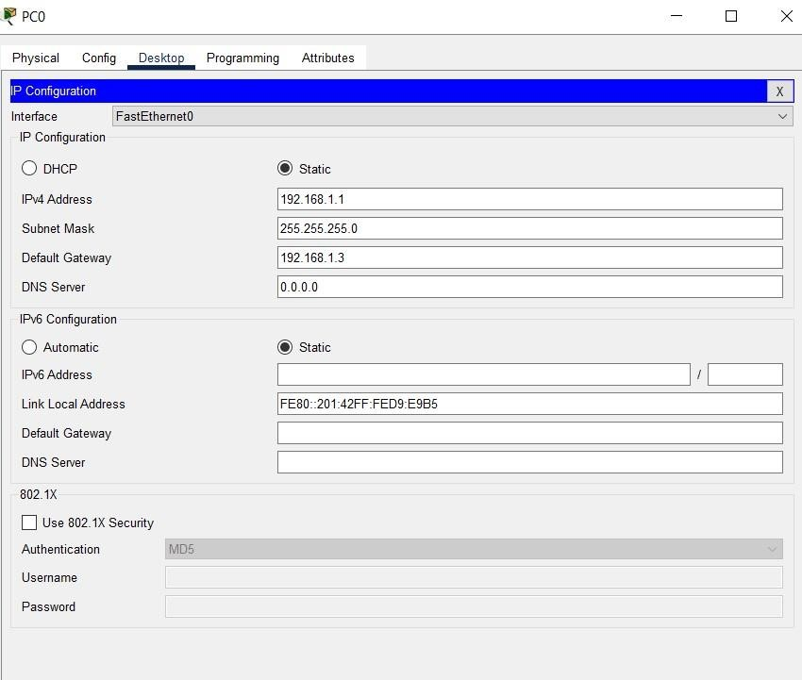

Similarly setting for router
(config-fastethernet 0/0 for the networks connected pcs)
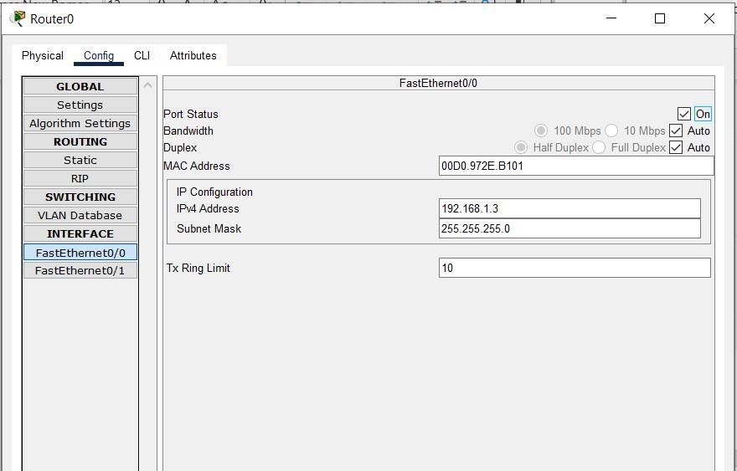

Set Ip address. Subnet mask will appear automatically. Click on “on” on the top.
For router to router connecting network ((config-fastethernet 0/1)
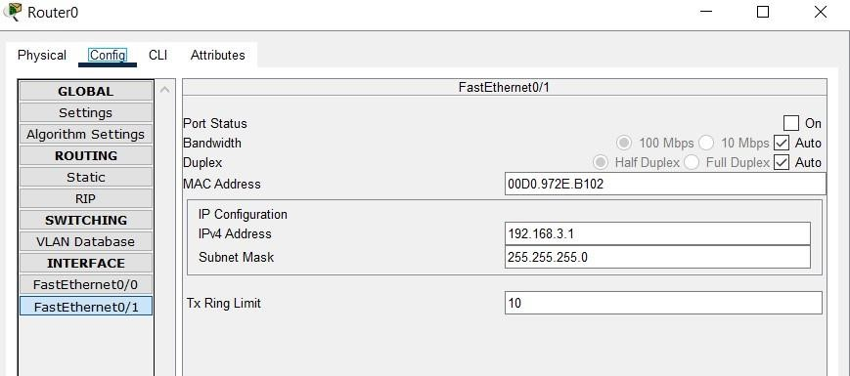

Set Ip address. Subnet mask will appear automatically. Click on “on” on the top.
Now the router-to-router connection is required.
For this for the router in network 1, set the following from config then static
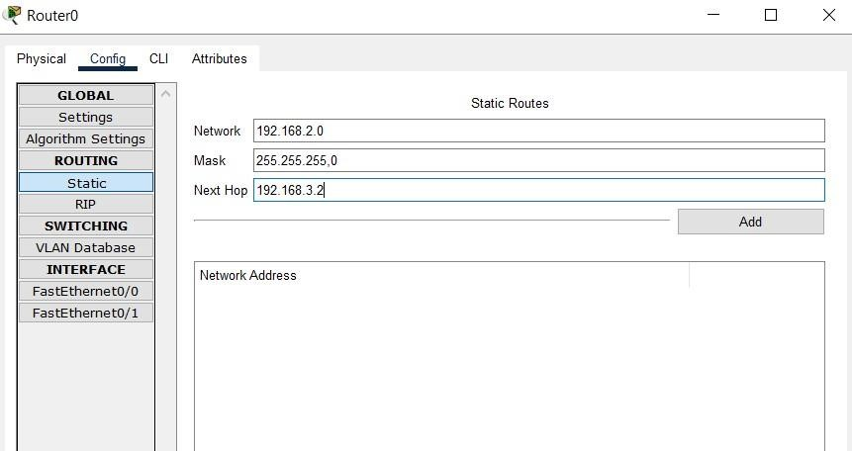

Click on add
For the router in network 2, set the following from
Click on add
Now check message passing from pc no 3 to pc no 0. It is successful
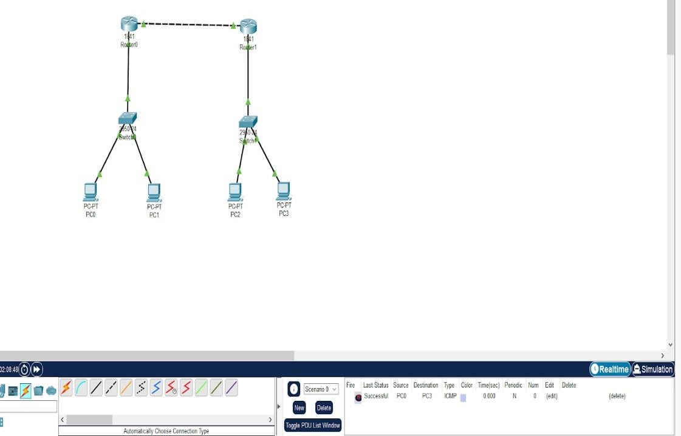
EXPERIMENT NO. 7
AIM: To implement an IP Addressing Scheme and Subnetting in small networks using Cisco Packet Tracer.
Subnetting:
The practice of dividing a network into two or more networks is called subnetting. Creating a subnet by dividing the host identifier. Computers that belong to the same subnet are addressed with an identical group of its most-significant bits of their IP addresses.
Steps:
Develop a network using a router (2811), two switches (2960-24TT) and four PCs
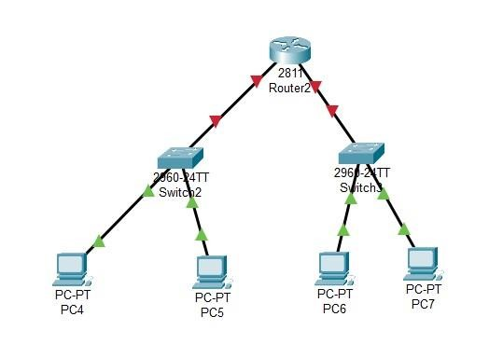
Then configure the IP addresses in each pc
Here subnet mask will be divided in to two parts so instead of 255 we have to take 128

In one side
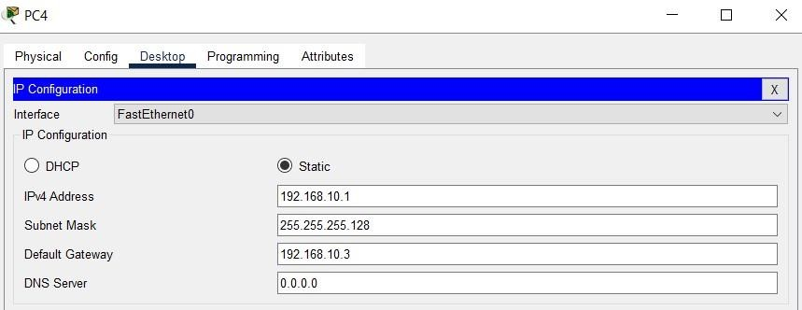

In the other side
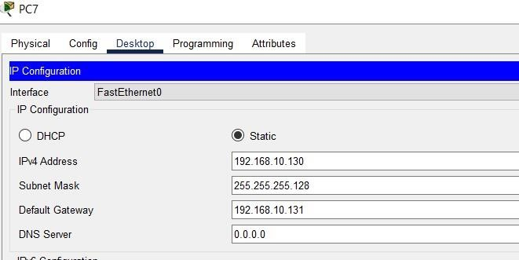

Then configuration for the router for both fastethernet 0/0 and fastethernet 0/1

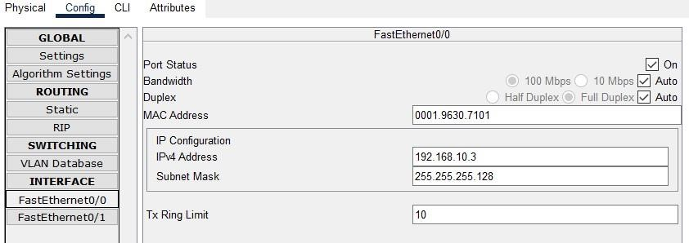

And

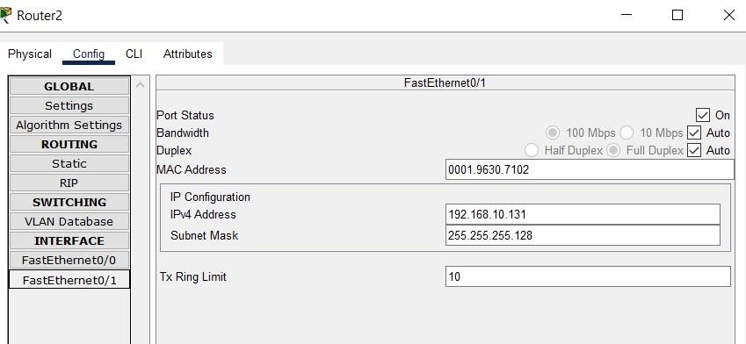
Then check the message passing is successful
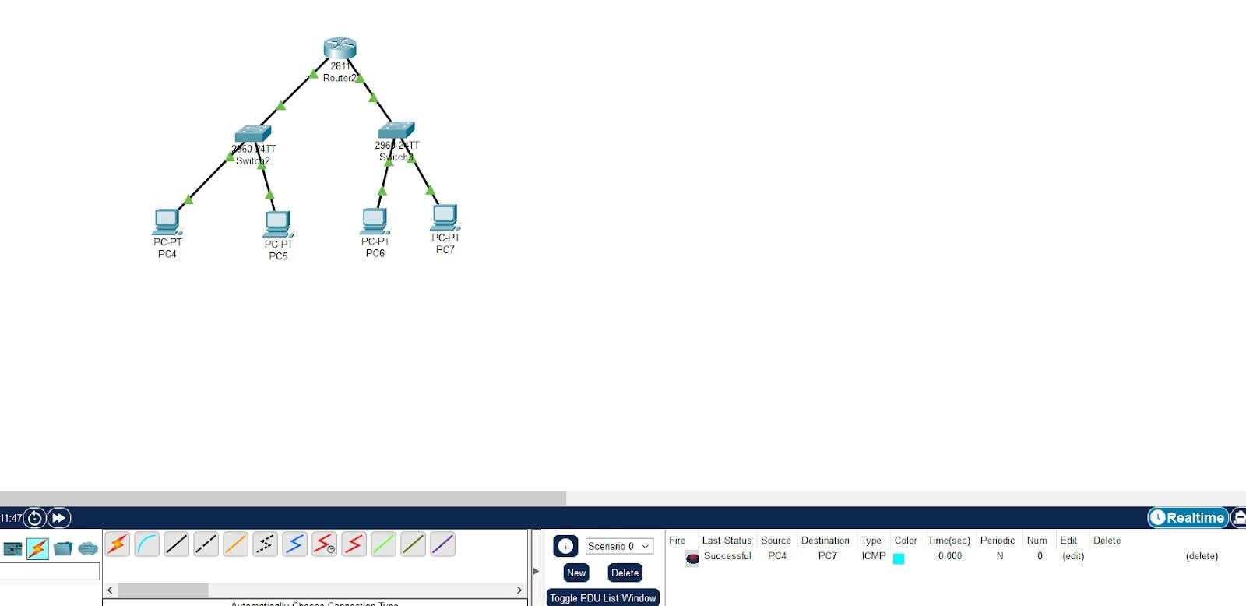

EXPERIMENT NO. 8
AIM: To Connect two LAN networks through Router.
Introduction to the packet tracer interface using a LAN network
Step 1: Start packet tracer
Step 2: Choose switch then select generic
Step 3: After selecting generic click on the main area.
Step 4: Select end devices and then click on generic.
Step 5: click at workspace to see the PC.
Step 6: select connections from power cycle devices and click on automatically choose connection type.
Step 7: Draw connections from switch to PC.
Step 8: Double click on a PC, a box will appear, click on the Desktop tab.
Step 9: Then select IP configuration.
Step 10: Write the IP address of your network and click at the Subnet mask filed.
Subnet mask will appear automatically.
Step 11: Repeat step 10 to set the IPs for all the PCs.
Step 12: Now add a router and repeat the above step for connecting second LAN.
Step 13: The second LAN would be configured with different class of IP.
Step 14: Configure the router’s fast ethernet ports to the IP of both classes and green light will blink.
Step 15: Now to connect both LAN, we need a gateway which is set by configuring the gateway of each device in the LAN with it’s router IP address for that particular class.
All the lights turn green and both the LAN would be connected.
Step 16: Select “Add simple message”.
Step 17: Drag and drop the message to the source device and then to the destination device.
Step 18: Observe the path of the message from source to switch. Then to all devices and then move to the destination.
Step 19: Finally observe the marks. If the source PC is marked correct it means you have successfully established connection.
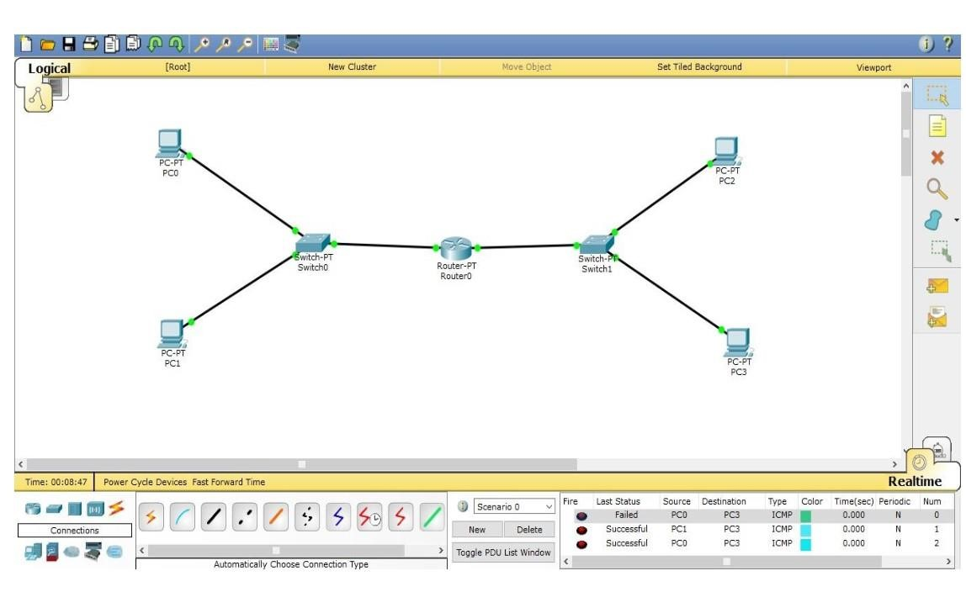
EXPERIMENT NO. 9
AIM: To implement the DHCP onto the Network Topology using Cisco Packet Tracer.
DHCP:
Dynamic Host Configuration Protocol (DHCP) is a network protocol used to automate the process of configuring devices on IP networks. it's the standard mechanism to dynamically assign IP addresses within a network.
Steps:
Develop a network using a server (Server-PT), a switch ( Switch-PT) and few no. of PCs.
Here three PCs are taken
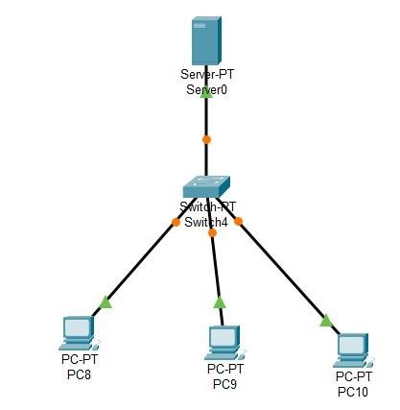

Set the configuration in server
First from desktop – Ip configuration, set the following
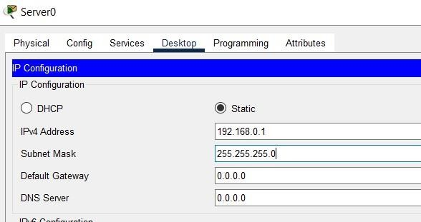

Then go to services click on DHCP then set the following
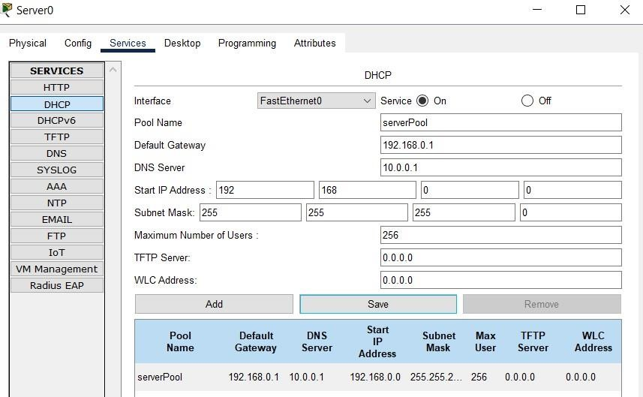

Click on “on”
Set default gateway, DNS server then click on “save”
Back to the end devices
Set the following in PCs Desktop- Ip configuration
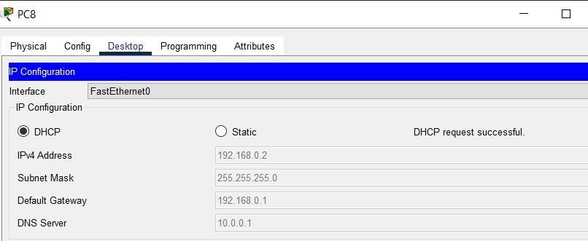

Click on DHCP, The Ip address will appear automatically.

EXPERIMENT NO. 10
AIM: To implement the Email Services in the Network using Cisco Packet Tracer.
A mail server (sometimes called an email server) is a software program that sends and receives email Steps:
- Make the network
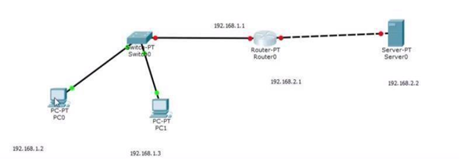

- Set all the Ip config as shown from Desktop-Ip config in end devices
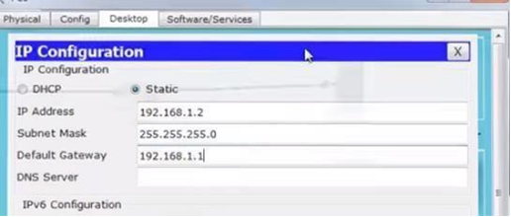

- Set the router ip address also.
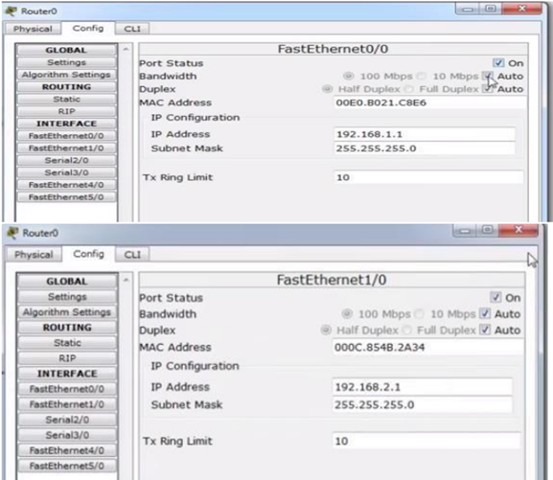

- Set the IP Config in server
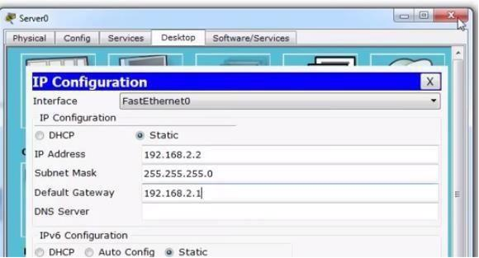

- Set the service in server
Click on services then to setup Email, click on EMAIL
Then set the Domain name and click on set. Here we set Email as example.com
Then User and password are need to be added. Here we set user as user1 and password 123.
Then click on + . We can create a number of users by adding this way.
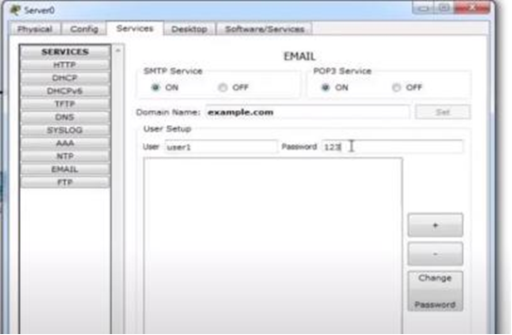

- Then go to the end device and set the following
From desktop choose configure mail. Then set the details as follow and save.
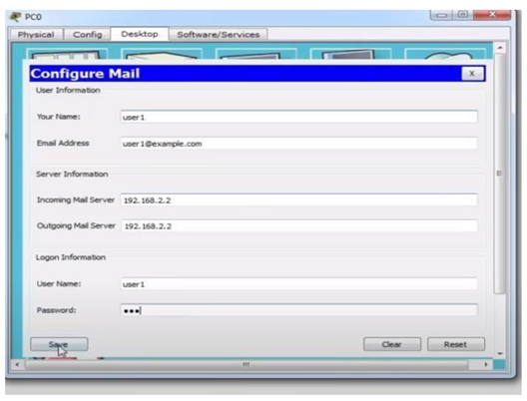

- Then from desktop click on Mail browser then compose mail.
In that compose mail fill the details liketo, subject and then message. At last click on send
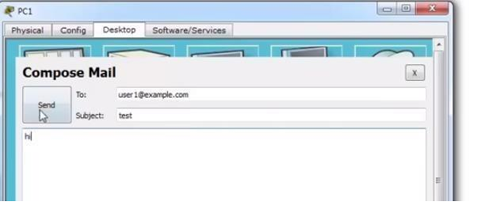

- Then from the other pc click on desktop then mail browser.
Then click on receive, it will show the received message. Click on the message, the message will appear below.

EXPERIMENT NO. 11
AIM: To implement the DNS server in the Network using Cisco Packet Tracer.
DNS servers translate domain names into IP addresses, enabling DNS clients to reach the origin server.

Learn about the different types of DNS servers.
Steps:
- Design the network first
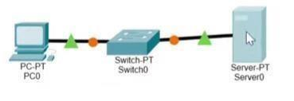
- Set the server ip.
Choose Ip configuration from desktop. Fill IP address and DNS server. Make sure both are same.
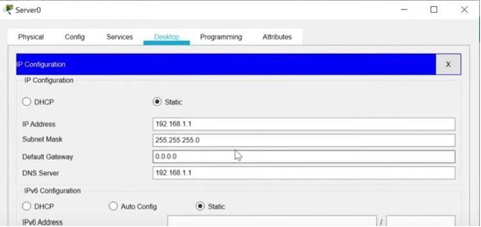

- Then click on services. To make a website click on HTTP
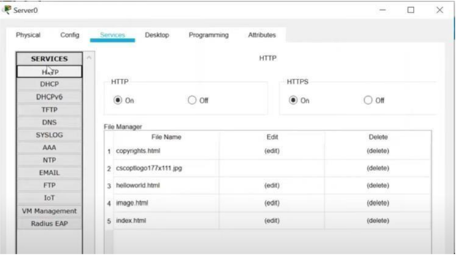
- Go to any website name, for example last one index.html click on edit button. Change the codes as per your choice and then click on save. It will ask about overwriting, click yes
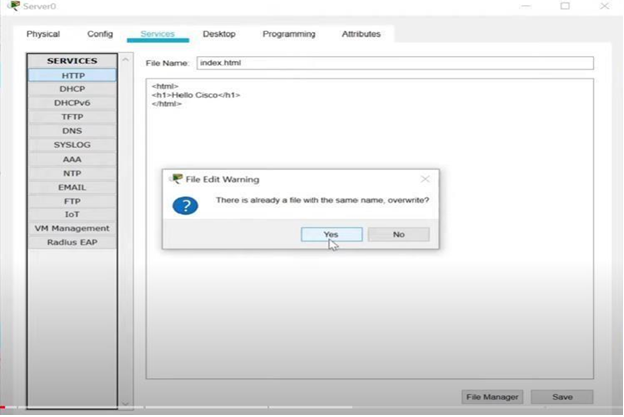

- Second setup in server only.
Click on DNS from left side then click on the DNS radio button. Fill the web site name and address.
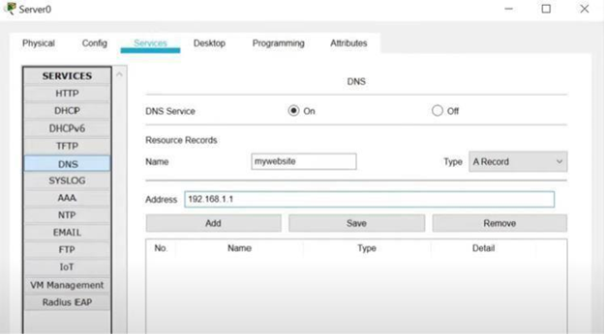
The address is the Ip address of the server only. Click on add. The name reflect below.

- In the end device assign the IP address and DNS server. DNS server is the ip address of the server only.
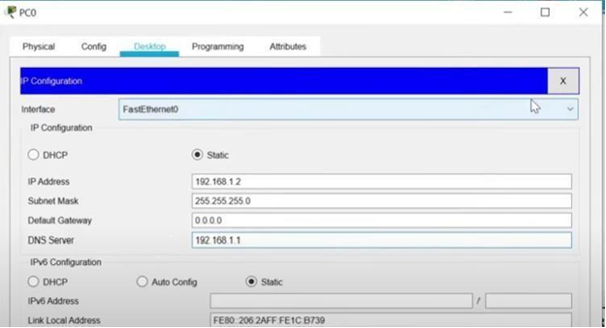
- From desktop only select web browser. Write the website name and click on go button then the web page is visible.
